OCTOBER / NOVEMBER ISSUE 2020
W

elcome to the Traditional Touring Clubs third newsletter. Again l have had so much positive comments, which l find so encouraging as you can imagine it’s time consuming putting it all together. A massive thank you to Sue Alder for her time and skills in composing this very professional newsletter.
The club was just about getting walks and cycles up and running, with a full trip sheet up to Christmas, when the announcement came out about another lockdown. At least we did have a walk and a cycle on the week just before Thursday 5th November; a trip sheet will be sent out shortly, however it will be pending on what restrictions are imposed, let’s see what happens after 2nd December.
Government ministers have called walking ‘Active travel’ to describe the pleasure of putting one foot in front of the other, well l suppose this is the only thing we have been encouraged to do throughout this pandemic. So many other things, like socialising, travelling or sports etc have been heavily restricted. Walking has become a lifeline to many, during this lockdown, l am amazed at how many people are out walking on the seafront and in parks, of course the weather has been so warm for November.
I was given a Saga magazine by a friend recently, whom most of you know, she has a Liverpool accent (big clue). In it was an interesting article about walking, did you know there is a a right way to put one foot in front of the other. According to Joanna Hall’s walking techniques (joannahallwalkactive.com) walking properly would burn off calories, lower your risk of blood pressure, high cholesterol and type 2 diabetes, also help our posture and calm us down. She says ‘everyone should take their dog for a walk every day even though they don’t have a dog’. She also says that ‘many of us don’t walk properly and therefore don’t reap all the possible rewards’. All this said, l read all the techniques adviced by Joanna and off l went walking, with Holly. Firstly, l forgot most of the points, l did number one with the Velcro but soon got fed up with this. I liked the neck and shoulders and was able to concentrate on this, it reminded me of Pilates ‘getting your body in the right position’. Secondly, my arms couldn’t flow like a pendulum because l was holding a dog lead, but when she was off the lead l tried this. My conclusion is that l need a lot more practice and l feel it would be more beneficial if l was with someone who is committed to this technique and thereby encourage me to do it properly. Cheaper than a gym l suppose, however l walk for fun, social enjoyment with friends chatting about nothing and everything. Give it a try you will more than likely be better than me and probably enjoy it, good luck.

Sally Meredith (President)

CLUB ACTIVITIES:
The club was able to put on a few walks and cycles this month, many thanks go to the leaders. We were planning more walks and cycles but are now having to postpone these due to the second lockdown. Hopefully we will be able to continue where we left off after 2nd December. We always need volunteers to lead activities, please let any committee member know if you are willing to help. If you have anything that you would like to contribute in next month’s issue please let Sally know, it could be festive related! Many thanks go to those who have taken the time to write about activities and send them to me so that this newsletter can keep you entertained during these solace times. Special thanks to Sally as always.
O

Stuart’s Cycle

n Wednesday 7th October six intrepid and discerning cyclists ventured out on the “TAKE ME TO TERLING TODAY” ride. The autumn weather was fine and sunny with a breeze from the south. Following extremely quiet byroads the group headed to the Owls Hill tearooms where the local Terling Teacakes proved popular and enjoyable accompanied by various coffees. Many subjects were discussed as we sat outside the tearoom and put the world to rights. Martin revealed that he had been quite a proficient archer in his day and had once fired an arrow through a bramley apple at 100 paces ( I believe his quiver is also something to behold). He was also wearing a rather fetching hand-knitted skull cap which encompassed concentric rings of red, white and blue and when he bent down it made him look like a target for an archery contest. The return journey now used a combination of Farm concrete bridleways and traffic free byways (newly discovered by our trip leader) plus the usual byroads before returning to the Compasses pub. It is amazing in this day and age that it is still possible to ride nearly 20 miles in the attractive Essex countryside with so little other road traffic. Back at the pub 4 of the group enjoyed food and drink whilst continuing to put the world to rights. Another successful TTC outing.

Stuart Budds (trip leader)

Anna’s Walk

“T
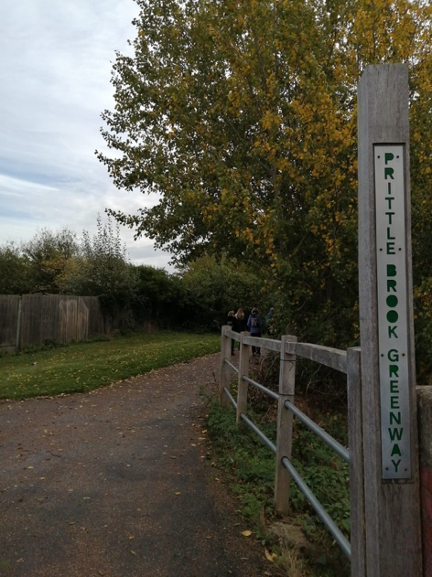
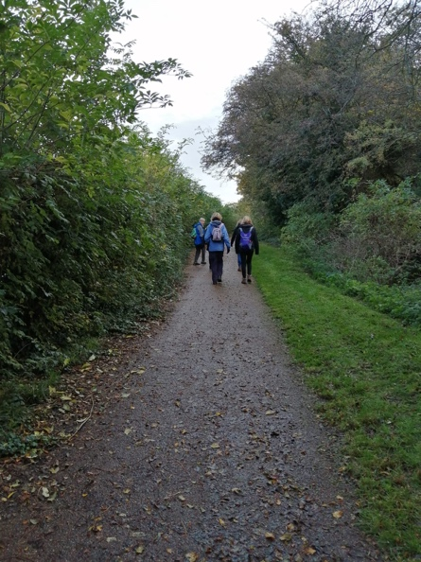
he meeting up guideline for Anna’s walk was ‘by the exercise equipment in Bonchurch Park.’ I duly entered the park and was confronted by an impressive array of keep fit and play area choices including an area with some quite serious exercise equipment. Needless to say, thankfully, the attendees on the walk were not actually to be found in this latter exercise area but sitting and chatting on normal park benches in the centre of the park. Off we went along Prittlewell Brook. I have in the past done some walking along the Green Chain series of walks that provide unexpectedly pleasant and tranquil walks in an otherwise potentially unpromising landscape in suburban South London. I think the Prittlewell Brook walk provides something similar in our area as it flows gently from Belfairs to Priory Park passing allotments, school playing fields and other green spaces (that would otherwise go unnoticed) on the north side of the brook and (for the most part) the back gardens of houses (some with fences perilously close to concrete bank of the brook) on the south side. With enough trees to provide cover from the sun in Summer and the well signposted gravel path providing a mud free walk in Winter it really does provide a walk for all seasons. Upon arriving at Priory Park we relaxed with cups of coffee, admired the trees changing colour in the park and then retraced our steps back to where we started. The walk is just over an hour in each direction - and if we end up in lockdown again (as subsequent to this walk we now have) it is an ideal way to while away some spare time.” Robert Wright

Clifford’s Walk

H
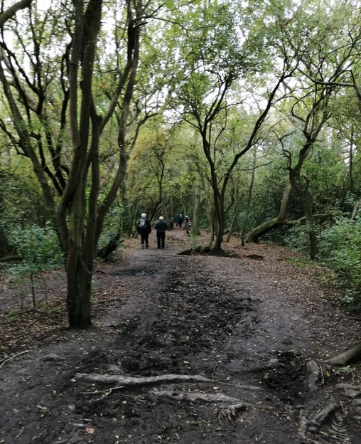
ockley Woods Walk – Sunday 18 October. Never having been to Grove Wood before I was thinking ‘where can I park? Grove Road presumably?”. It was thus a pleasant surprise to find a tarmac road leading off of Grove Road directly into a nice little car park in the wood itself. The disastrously wet weather of earlier in the week had led Clifford to consider cancelling the walk but the more clement conditions of later in the week had rescued the situation and Clifford was able to skilfully steer a course through the woods and surrounding countryside that (apart from the first 200 yards) was largely free of heavy mud. Sunday was in fact a very good day weather wise – dry, mild, no wind. This led to plenty of people other than intrepid TTC walkers being out in the woods – an assortment of family groups, cyclists and dog walkers etc. The mobile food and drink van served as a welcome coffee stop before heading back to our start point. A very pleasant way of spending a few hours on a Sunday. Thanks to Clifford for an excellent walk.

Robert Wright

Stuart’s Cycle

O
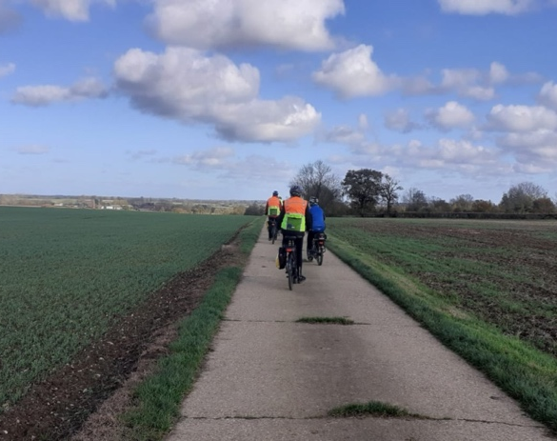
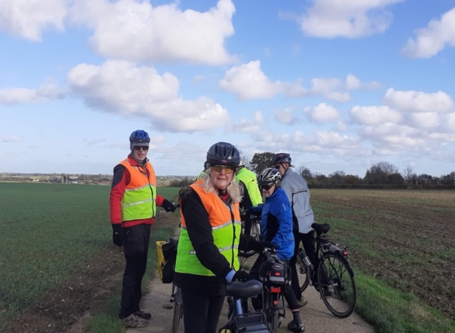
n 4th November, 8 socially distanced members of the elite mounted division of the TTC assembled outside the Compasses pub at Littley Green. During the previous 3 days we had endured grey sky’s,rain and constant gusty winds. On the 4th the sun shone out of a clear blue sky, there was the mearest hint of a wind, the air was crisp and even. What’s more the Autumn colours of the trees and hedgerows portrayed nature at its best. All was well with the world except that on the very next day we were to be in lockdown. Initially we headed East then North followed by a bit of West as we passed by Leez Priory, Cock Green, Cobler’s Green and then Felsted before heading to the Snug Cafe at High Easter. Sitting outside in the sunshine whilst drinking coffee, eating cake and bread and butter pudding plus pleasant conversation was delightful. Continuing on into High Easter we headed to Pentlowend, Sworders and then to Blunts where we followed the lovely concrete farm tracks beside open fields with splendid views across the Essex countryside. Then it was back to Littley Green via Hartford End. 20 miles of idyllic cycling along the very quiet lanes and byways. Several of us then ate and drank outdoors before heading home. A cracking day out. Stuart Budds (trip leader)

Robert’s Paglesham Walk
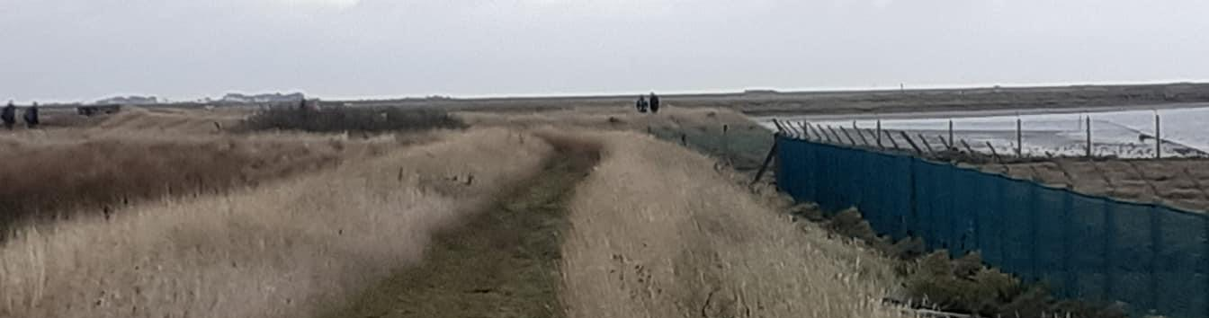

T
he last day of September was forecast to be the last day of decent weather before a few days of rain of potentially biblical proportions. Rain was in fact forecast for early that afternoon presenting an interesting challenge as to whether we could complete the walk in the dry. Soon after starting off it started to drizzle and just as I was fearing the worst the sun broke through the cloud and it was quite warm for an hour and dry for the remainder of the walk.

Sally had done a great job of trawling through Cycling UK and Ramblers websites to fathom out a modus operandi for TTC walks and cycles in the light of the tighter Government Covid restrictions (rule of 6 etc.) Having done a recce with Sally and her four legged partner in grime Holly I gave an upbeat ‘risk assessment’ with a couple of things to look out for (one fairly steep slope off the sea wall and 400 yards of main road walking) and off we went in two groups of six from the overflow car park opposite the Plough and Sail pub.
Our route took us on a path that led past quite a busy little marina with an
industrial unit, a marine engineering centre, quite a few boats and onto the sea wall next to a jetty that had two or three quirky buildings on top of it including one that appeared to be a somewhat down at heel clubhouse.

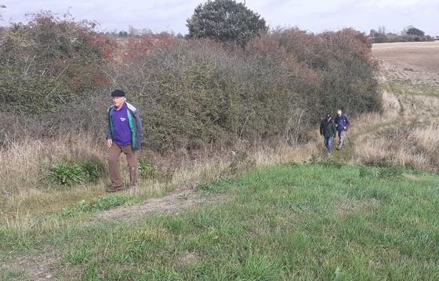
As the sea wall curved round, Burnham on Crouch could be clearly seen in the distance and then the sea views ceased for a while as we left the sea wall - it was quite a steep slope down!- and we were rewarded with easy walking along good tracks through farming territory (most of the crops seem to have been harvested but there were a few tractors still ploughing the fields). Flat landscape; big sky country. The stretch on the main round (which was safely negotiated) took us past South Hall a lovely two storied south facing brick built mansion house with an immaculate, almost ornate, front garden. Leaving the main road, the path took us past South Hall Farm and onto a wooded section of the Roach
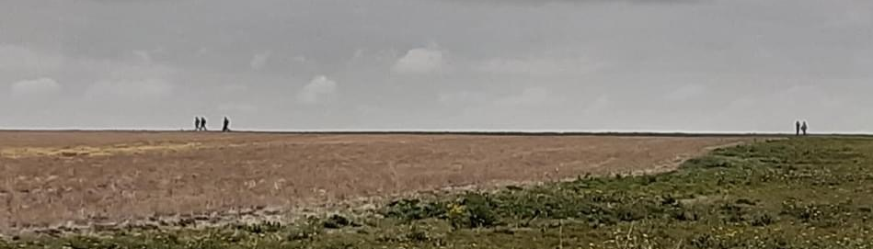
Valley Way and past the driveway to Stannetts which revealed itself as an impressive pink painted clapperboard building faintly reminiscent of New England. Back out into open country we passed the edge of an impressively large lake heavily populated by a variety of
ducks, geese and swans. Heading towards a distant treeline our path turned left and down to a farm called Barton Hall where we turned left again and passed a yard containing huge loose piles of cockle shells and more cockle shells in large bags. The path took us down towards the sea wall and for about 800 yards was lined with these shells – the white cockleshell road rather than the yellow brick road. Bizarre – I reckon you could have followed it in the dark. Back on the sea wall, the jetty and its quirky buildings were clearly visible in the distance and a longish but easy stretch of walking got us back there and soon thereafter to the pub.
The hospitality at the Plough and Sail was most welcome. We retired to the marquee for drinks and half priced food. A most enjoyable end to an enjoyable day.”

Robert Wright (trip leader)

Jackie’s Monday walk

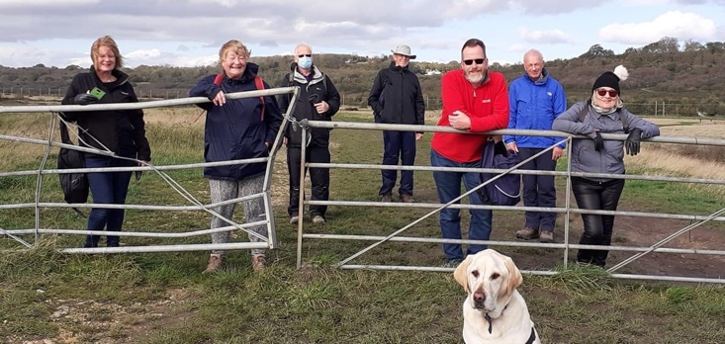
Monday 2nd November, the last TTC walk before lockdown. I rarely do the Monday walk but l am so glad l did. There were eight of us walking towards Benfleet on a very blustery day, with the wind against us, it didn’t rain so that was a bonus. We all chatted and walked avoiding large muddy puddles, however Holly didn’t she just ran through them so she was covered, she had a lovely time and when home she slept for about 4 hours. I on the other hand didn’t, l tidied the garden and did some cooking, but you don’t need to know this.
Photo at the gate was taken by me, on Jackie’s absence and duly put on Facebook. Four people went to the pub and the rest of us walked back, including me. Walking back was easy with the wind behind us, we got back in no time chatting and putting the world to rights. It was lovely to catch up with friends knowing that a four week lockdown was approaching, and that we wouldn’t see each other for a while. Walking in the fresh air with nice people does help my mental well-being and l hope it does the same for others.
Thank you for all who came and for the regulars who support the Monday walk, it certainly has been popular over the years. No more TTC walks or cycles after Thursday 5th November for four weeks so keep safe and see you all, hopefully in December. Sally Meredith

The Allotment

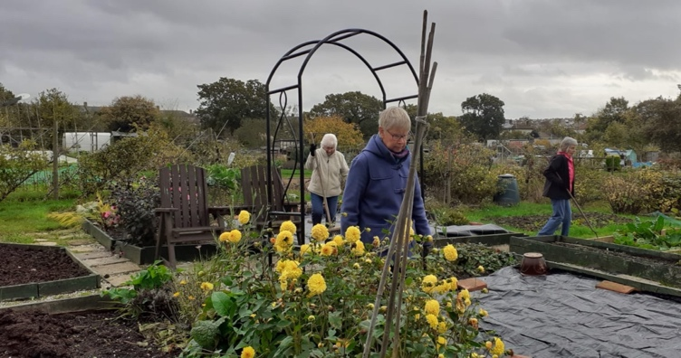
Life at the allotment

The weather throughout the Spring and Summer has been glorious, but for the allotment it meant constant watering. Watering is a chore and not a job enjoyed as we have to fill up watering cans from a trough and carry them to the vegetable patches. We watered early evening and sometimes in the afternoon which is not ideal, however some watering was better than none at all, as long as the roots got the water and not the leaves. Nevertheless, there was a good produce of beetroot, onions, courgettes, cucumbers, potatoes, pumpkins,
leeks, tomatoes and many other things. It is a great community over there and has helped many through the lockdown and the imposed restrictions, we meet to work on our plots, to have a Norman cuppa and a chat. What a peaceful place to be watching our produce grow, and connecting to nature.
The girls, plus our new recruit Anna, help in the new cafe which has just opened for drinks and a snack, Saturday is the popular day for meeting and we all help each other with the weeding etc (no watering of plots now). I must say our two plots look fantastic thanks to everyone’s hard work and skills, l personally have learnt so much about planting and produce from others more knowledgeable than myself. A big thank you to all who work so hard over at the allotment and making it a peaceful place for us all to enjoy. May ‘The Good Life’ continue.
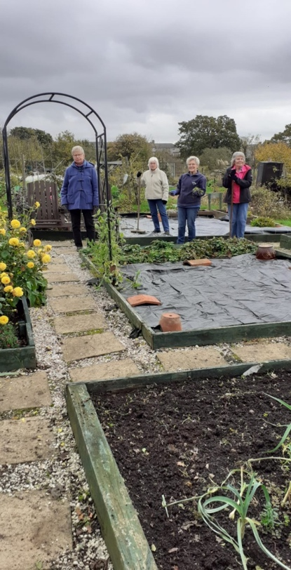

Sally Meredith

Book Club
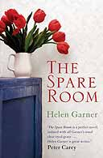
The Spare Room by Helen Garner – Average score 6 points

Some of the comments given via the on-line meeting:

A difficult book on a difficult subject so not of course an ’easy’ read as such. Some quite good black humour but the overall picture is of Helen finding the situation that she has been placed in as becoming more and more intolerable and of Nicola being in denial (until very late in the book) about her own survival chances. Nicola’s inevitable passing is depicted quite well by the author.
My score is 7 points.

I read it quickly and it was an easy read - a short but a powerful book about Helen’s account of looking after her friend Nicola with cancer. Their friendship is tested to the limits as Nicola is adamant that she is going to have unconventional alternative cancer treatment at a clinic. Here she endured ozone tents, intravenous vitamin C and coffee enemas. Helen looked after her for three weeks under very stressful conditions, as Nicola refused to see her treatment was making her so ill with pain, sweats etc. I felt anger towards Nicola as she was exposing her family and friends to looking after her without backup from conventional healthcare. She had this ‘darling Hel’ approach with a smile that was stuck on her face. I felt anger towards the clinic for taking her money and giving her false hope when it was obvious she was not going to get better, and Nicola again, as an intelligent person, was oblivious of their intentions. Helen, l thought, did have a nursing background, but l think she must have had experience of looking after someone with cancer. This book was well written and did make you think that a dying person will cling on to hope where ever it comes from. As a nurse l often came across people who preferred alternative medicine, and l did respect that. But it’s also about being honest with yourself and your family and friends. This book was funny in places, sad, annoying and frustrating - and l’m glad that it was only over three weeks. It did end a bit quick, probably because there wasn’t much more to say. My score is 7 points

I read this book twice – but I still couldn’t get really involved in it. I’m glad that I tried to get to know the women in it – but it didn’t work for me. My score is 6 points.

A disappointing read. An interesting subject which could have made a good story. Sad, annoying at times and depressive. Not for me. (I thought that the author was a novice, but apparently not!!) My score is 2 points

The Spare Room is an easy read – it tells of a terminally ill lady clutching on to any off the wall treatment hoping for a cure. Her carer finds it all exhausting seeing her friend so sick. Not a book that I would recommend. My score is 4.5 points.

Club Corner

Sally’s delicious Apple Streusel Cake

INGREDIENTS FOR THE TOPPING:

50g / 2oz Pecans
50g / 2oz Plain Flour
25g/1oz Soft Dark Brown Sugar
25g/1oz Butter, Diced

INGREDIENTS FOR THE CAKE:

140/5oz Unsalted Butter Softened
140/5oz Light Brown Muscovado Sugar
2 Large Eggs
225g/8oz Self-Raising Flour
1tsp Baking Powder
1tsp Mixed Spice
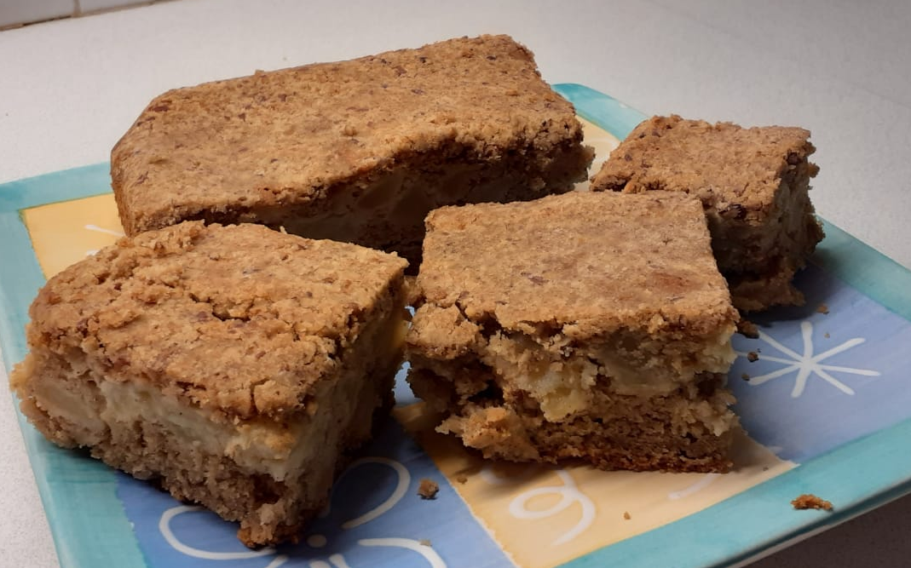
3tbsp Milk
500g/1lb 2oz Eating Apples, Peeled, Cored and Diced

METHOD:

Heat the Oven to 180 Fan 160 Gas 4.
Line a 20cm/8 inch round tin with baking parchment, leave a 1 inch collar above the tin.

Place the topping ingredients in a food processor and blitz to a crumbly texture. Set the bowl to one side.

To make the cake - beat the butter and sugar with an electric whisk until light and fluffy, gradually add the eggs one at a time, continuing to beat until fully combined.

Sift the flour, baking powder and mixed spice, followed by the milk and apples, then fold everything together.
Spoon into the prepared tin and sprinkle over the streusel topping.

Bake for 1 hour 10 min but check a skewer comes out clean from the middle. Remove to a wire rack to cool completely.

A Story by Ken Ploughman

Part 1: THE ADVENTURES OF A LITTLE RIVETTS BIKE - a light hearted account of the life of a Rivetts frame
Some 55 years ago (circa 1952) a keen young lad, embarking on the threshold of a cycling career, installed into him by his father, walked into Rivetts cycle shop in Leytonstone High Rd to buy his first brand-new lightweight road frame.
It was hanging on the wall, a 20 1/2 inch gun metal grey road racing frame, emblazoned with the name “Rivetts” on the down tube. This was not the name of the craftsman who built it, that honour went to Denis (Slash) Beals, a member of the Comet C.C who I got to know very well during my life. I eventually joined the Comet C.C and stayed with them until they amalgamated with he Crescent Wheelers and we became the “Lea Valley Road Club” recently changed to the ‘Lea Valley Cycling Club”, which I am still a member of.

So handing over my hard earned pocket money, this fabulous little Rivetts frame with the delicately cut Nervex lugs which could have been made to measure just for me became mine. I don’t know how, but I also managed to afford Campag equipment, so the next few days were spent fitting all this gleaming jewellery.

So our great adventure together was about to start with gentle rides at first round the Essex lanes to let her get the feel of the road. Eventually she would thrill to the excitement of road racing, swept along with the tide of the bunch going as fast as my legs could make her go. Then there was just the two of us alone battling against the clock in time trials on the E1 course. Nothing outstanding was achieved , rides below average even, but still fighting our own personal battle with time.

This little Rivetts bike was to get to know the E1 course very well during her life, not just racing but on the many rides round the lanes that branched off this very famous course.

So the years and the miles went by. Then one day a buff coloured envelope fell through the letter box. My country was calling for me. I was old enough to do National Service. So with great sadness I gave her a protective covering of oil and gently placed her in the cellar, not knowing when we would hear the wind whistling through the trees or feel the rain beating down upon us. Fortunately, it was only to be about seven or eight weeks. After basic training at Blandford I was transferred to Taunton in Somerset where I was to spend six months on a vehicle mechanics course. I soon found out that we were allowed to have our bikes on the camp, so at the first available 48 hour pass I was home to retrieve her from the cellar and restore the elegant shine to her 531 tubing. The next six months, every Wednesday afternoon, which was reserved for sports, we would pass together through the camp gates to lose ourselves amongst the rolling Somerset countryside and for a few hours forget the spit and polish of army life.

The six months soon sped by and when the postings went up I discovered I was going to Germany. Once again it was the parting of the ways. We returned home together on embarkation leave and my little Rivetts with all her shiny fittings was again made comfortable in the cellar with the knowledge that she was going to have at least 18 months rest.

They passed quickly by and demob day arrived. On arrival home the Rivetts was soon retrieved from the cellar to greet the warm rays of the sun, none the worse for her long stay underground. With a few hours spent on her, cleaning and oiling she was soon restored to her original splendour.

Now plans were afoot for our next great adventure together - a trip across the channel for a tour of Austria and Italy. On arrival at the French port we boarded the “Ariberg Express” one of the great continental trains which would eventually finish its journey at Istanbul. It was with great reluctance that I let a railway porter take my ‘Rivetts” away from me and deposit her in the luggage van, but he assured me she would be in safe hands. Soon the train was rolling through the French countryside, rather uninteresting at this point, but as we approached the Alps so the majestic scenery began to unfold, through Switzerland it became breath-taking.

Some thirty six hours later the express rolled into the Austrian station of Spittal where I was quickly reunited with my beloved “Rivetts”. We looked forward to the next fourteen days with excitement. Together we would be discovering the delights of a new country.

From Spittal we set off, travelling through quaint little villages, negotiating the forbidden mountain passes, eventually arriving at the foot of the Gross Glockner, the highest mountain in Austria, and probably the hardest climb of the tour. We eventually made it to the top where we rested and gazed in awe at the view which lay before us and the peaks above where the snow never seems to melt. The decent down the other side of the Glockner to the chocolate box village of Heiligenblut was exhilarating to say the least. The Rivetts revelling in the speed in which we hurtled round the hairpin bends without a thought of danger, her sturdy joints taking the bumps in her stride…

Did they make it? What adventure comes next and where? Read Part 2 next month!

In the spirit of Christmas from Sally:

I got a Christmas card full of rice in the post today...
I think it was from my Uncle Ben

Stay safe.

