S
AUGUST 2020
ocial Distancing’ is the buzz words of 2020, as is ‘Stay Alert’ ‘Protect the NHS’ ‘Stay Safe’ rules and regulations to stop the spread of the COVID VIRUS. Lockdown gave us all an opportunity to work on the garden, get long awaited DIY jobs done, contact friends and family and take advantage of this fantastic weather by walking, cycling and water activities. Kitty O’Meara wrote this as the virus became a pandemic. “And the people stayed home, And read books, and listened, and rested, and exercised, and made art, and played games, and learned new ways of being, and were still. And listened more deeply. Some meditated, some prayed, some danced. Some meet their shadows. And the people began to think differently. And the people healed. And, in the absence of people living in ignorant, dangerous, mindless, and heartless ways, the earth began to heal. And when the danger passed, and the people joined together again, they grieved their losses, and made new choices, and dreamed new images, and created new ways to live and heal the earth fully, as they had been healed.” She suggests social distancing could be taken up by purposeful activities such as dancing, exercise and self reflecting, and suggests something other than darkness could come from isolation. Certainly we have seen a huge increase in outdoor activities, such as walking, cycling water sport activities etc. I know road traffic has increased now but when lockdown started there was a huge reduction in road traffic, which helped the environment, you could hear the birds, the air was cleaner, and cycling was so much more enjoyable and safer. I am missing this time and am still hoping that more people stay walking or cycling to reduce the amount of traffic on our roads, thereby reducing pollution and help the environment. Sally Meredith

CLUB ACTIVITIES:
The club has put on two walks and one cycle, thank you to the leaders. We are planning more walks and cycles but desperately need volunteers to lead these, please let any committee member know if you are willing to help.
O
Stuart’s Cycle
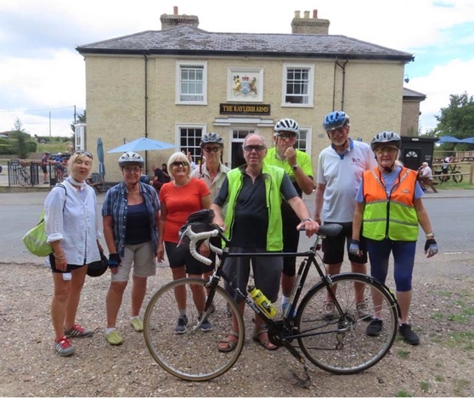
n Saturday 1st August 9 members of the elite mounted division of the TTC gathered at The Compasses pub in Littley Green. Several had arrived early and were partaking of light breakfast refreshments in the pub garden.
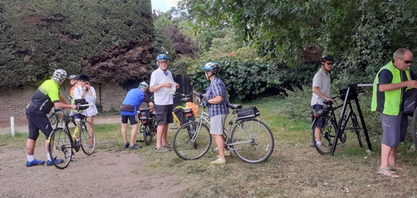
The weather was ideal and not too hot as the temperature on the previous day had broken records. This ride encompassed a number of firsts. It was the first official TTC ride since the lockdown. It was the first ride where a TTC cyclist wore a black horse riding helmet in lieu of a cycling helmet. This lady looked rather fetching in this somewhat unique attire and who knows she may be wearing jodhpurs on the next ride. It was the first time I have witnessed a TTC member donating 50% of his hand made Coffee and Walnut sponge cake (purchased at some considerable cost at the Owl Hill cafe) to a fellow rider who will remain nameless but does have a distinct Irish lilt to his voice. It was the first time that two members took social distancing to a whole new level by riding towards the Suffolk border when the rest of Us had turned left at a road junction. (this was the fault of the trip leader who had failed to mark the corner) The Country lanes and bridleways were fairly traffic free and we returned to the Compasses after 20 miles of extremely pleasant cycling. Five of us then enjoyed drinks and meals in the pub garden to round off an excellent start to hopefully more TTC rides this year.

Stuart Budds (trip leader)

Jim’s Hullbridge walk
T

en socially distanced walkers met at Ferry Road Car Park Hullbridge for a 6 mile Crouch Riverside & Countryside walk. Walking West towards Brandy Hole we saw the famous Australian Black Swan who has taken up residence in Hullbridge with it’s White
Swan relatives. We then headed South towards Cracknell’s Farm where we saw their herd of Alpacas & then crossed a stile into a field to negotiated our way through their herd of Cow’s. Continuing South past the Moat House we next encountered a large Alsatian & several little yappy Dog’s who barked us all past their territory’s. Undeterred we continued on, past the Lords Golf & Country Club to the Equestrian Centre where we walked between the paddocks of lots of friendly Horses & stopped for our picnic next to the Show Jumping Arena. After lunch we headed East along the edge of Blounts Wood where we encountered a large group of forestry workers & their vans & tractors, who were cutting back the trees & laying a new cinder track. After leaving the noise behind, we then turned North along the Blounts Wood Byway & headed back towards Hullbridge & eventually through the Cow’s field, past the Alpacas & past the Black Swan & it’s White Swan relatives. Back in Hullbridge we then all headed to The Smugglers Den for a well earned socially distanced drink.
Jim. (trip leader)

Sally’s Wakering walk

W
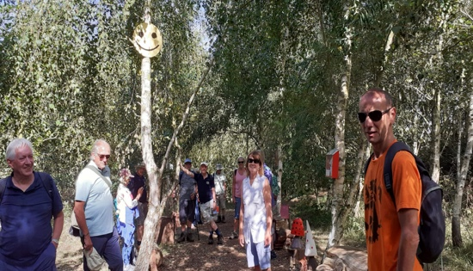
ednesday 5th August this was a beautiful day and perfect for walking. Seventeen TTC members, plus my dog Holly meet at 9.30am at St Nicholas Church, which was a great turn out. We walked down Common Road to walk through the Common. There is a volunteer group called ‘Friends of Wakering Common’ who have worked so hard in this area, they have made paths with woodchip taking you through the wooded areas. There are clearings with wooden climbing structures, swing from the tree branches for children to explore. You then go across to a nature fairy trail, with fairy houses, bug houses, lanterns, log seats etc. Its quite magical, and worth a visit, we all loved it and l won’t tell you what our average age was. From there we made our way through a farm onto the sea wall, with lovely views.

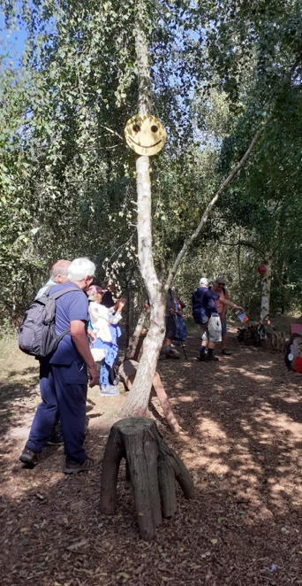
We were all spread out to keep our distancing, and walked quite a way along then down to the boat yard at the end of Common Road. This was an opportunity to shorten the walk for anyone, but no everyone wanted to walk on to the finish. The next part of the walk took us down a path past a fishing lake onto ‘Little Wakering Hall’ it is privately owned and a grade II listed building. We carried on round the back of the hall down a path, adjacent to a farmer’s field, over our one and only stile to a paddock of beautiful horses. It was here Holly meet her friend, a horse, she sat down as a horse came over and to my amazement they both looked up at each

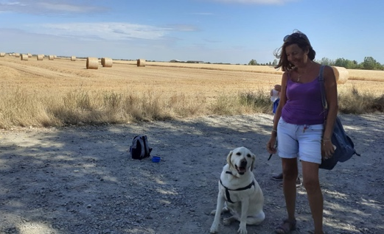
other, the horses bent over and they touched noses, and Holly licked her. A failed opportunity for a great photo, never mind. This led us out to Little Wakering Rd opposite the Castle Pub. The last part of the walk took us along this road to a footpath, which went around the back of Wakering Park where some of the group went in for a picnic. The rest of us went on past the allotments into Wakering High Street to the end of the walk. We ended up in a Pub called ‘Waeccer’ for a well deserved cold drink.
A few had never walked this route before and were very impressed with the area, so maybe l will do another walk in Wakering soon. Thank you to all who joined me on this lovely 6-7 mile walk, which me and Holly enjoyed, it was so great to see you all again after months of separation.
Sally (trip leader)

Jackies Monday walk
S
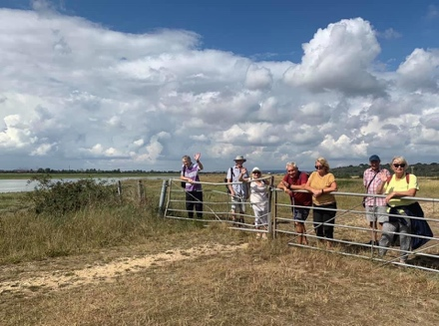
tart the day the Benfleet way, or rather - start the week with a five mile walk to Benfleet. Every Monday at 10.30am - come rain or shine - TTC walkers set off from Osbourne’s cockle stall (opposite the Crooked Billett) to walk to Benfleet. We did stop while the whole country was in lockdown of course - but we have started again - and now we are even ending at the Half Crown pub for a drink and lunch as before! We are mindful of social distancing - and the pub is observing all the cleaning and safe ordering processes - so we feel that it is safe. But you don’t have to stay for lunch - and you can walk back or return by public transport. As one of our regular Monday walkers says ‘it’s good to start the week with a walk - start as you mean to go on..’.
Jackie (trip leader)

Book club

Of course it was easy to keep people reading books over lockdown - but holding a book club meeting was far more challenging. We had a shaky start with our first Zoom meeting as Pat F could only communicate with hand signals as she couldn’t make her audio work. That was sorted by the next meeting - and from then on our virtual meetings became quite professional. Each month I also collected scores and comments and circulated these by email to everyone. That way we all managed to keep in touch with each other.
The books that we have reviewed ‘remotely’ this year were - Kevin’s choice ‘War of the Worlds’ by H G Wells average score 9/10 (in fact the highest score for our whole thirteenth year); Jacqui (G)’s choice ‘The Forgotten Village’ by Lorna Cook average score 4 points; Pat (F)’s choice ‘Little Women’ by Louisa M Alcott, average score 6 points; Pat (P)’s choice ‘The Bees’ by Llaline Paull average score 7 points; Ann’s choice ‘The Thread’ by Victoria Hislop average score 7 points and Rita’s choice ‘The Boy on the Top of the Mountain’ by John Boyne average score 7 points.
Then last week we actually managed to have a physical meeting again! Six of us sat, suitably distanced, on Maire’s decking in the warm setting sun to discuss her book choice, ‘Trilby’ by George du Maurier. We had an interesting discussion of an historic book which was really quite challenging to read - so the average score was only 4 points. But it was refreshing to have a discussion in person again at last ..
Jackie
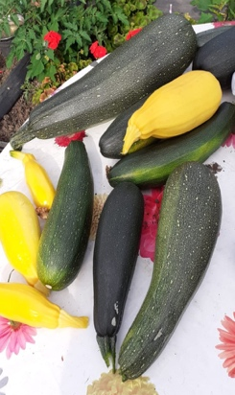

Club Corner

What do you do with the surplus Courgettes from the allotment? bake a cake!

Sally’s Recipe, Pecan, Courgette and Lemon cake

Ingredients:

175g pecan or pistachio (use what ever you have in the cupboard)
250g golden caster sugar
200g soft butter
280g plain flour
1 & half tsp baking powder
1 & half tsp bicarbonate of soda
3 large eggs
140g Greek style full fat yogurt
Zest and juice of 2 lemons
140g coarsely grated courgettes
175 icing sugar

Method:

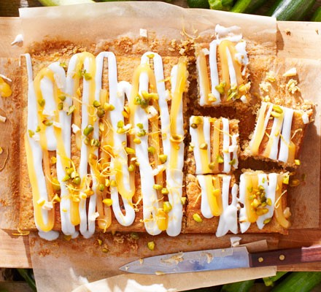
Heat oven to 180c/160c Fan/ gas 4. Grease a 20 x 30cm square cake tin and line the base with baking parchment.
Put nuts (Saving some for decorating the finished cake) and sugar in a food processor and wizz until The nuts are very finely ground.
Tip the nuts sugar into a big mixing bowl With the butter, flour, baking powder, and bicarbonate of soda, eggs, yogurt, and the zest and juice from 2 lemons. Beat with an electric whisk until smooth and combined.
Stir in the courgettes until everything is well mixed. Then scrape into the prepared tin. Bake for 40-45 mins (May take longer, mine did) until the cake is risen and golden and a skewer poked into the centre comes out clean. Leave to cool.
Remove from the tin. Sift the icing sugar and gradually stir some water to make a runny-ish consistency.
Drizzle this over the cake and repeat with some lemon curd, if you like. Decorate with the remaining nuts. Leave for a while to set.
FREE – these items have generously been donated to the club, and are on offer to all members. If you are interested contact Sally and she will reserve, for you. Whilst these are free, an optional, small donation to the club would be gratefully received.

Bike Floor Stand, put your front wheel in between the frame and your bike will stay upright.
Bike Hanger, fix it to your garage wall to hold two bikes.
Car Roof Bike Rack, note: a bolt is missing on one of the gutters.
